Wipro Date: 16/03/2000

Flow control statements:

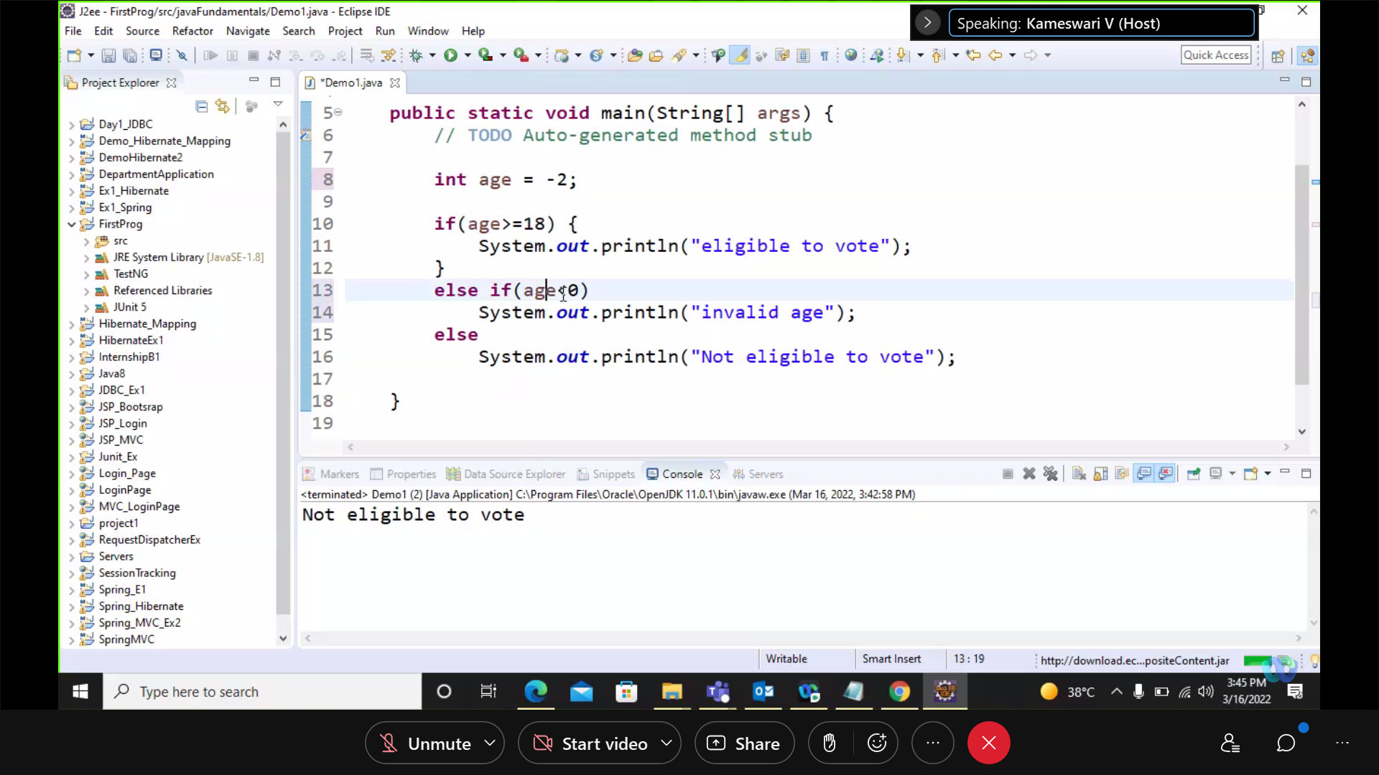

public class Demo1 { public static void main(String[] args) { // TODO Auto-generated method stub int age = -2; if(age>=18) { System.out.println("eligible to vote"); } else if(age<0) System.out.println("invalid age"); else System.out.println("Not eligible to vote"); } }

Switch:

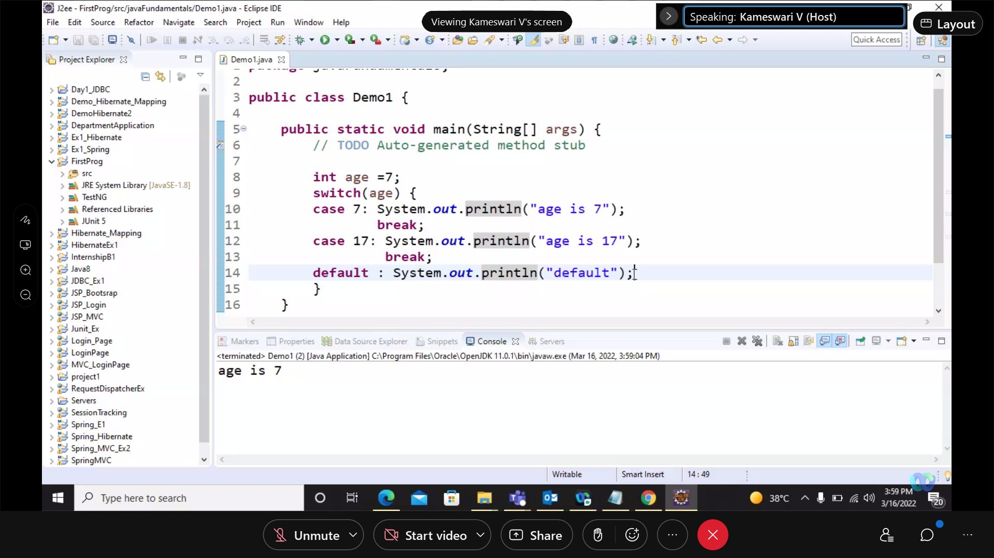

public class Demo1 { public static void main(String[] args) { // TODO Auto-generated method stub int age =7; switch(age) { case 7: System.out.println("age is 7"); break; case 17: System.out.println("age is 17"); break; default : System.out.println("default"); } } }

while :

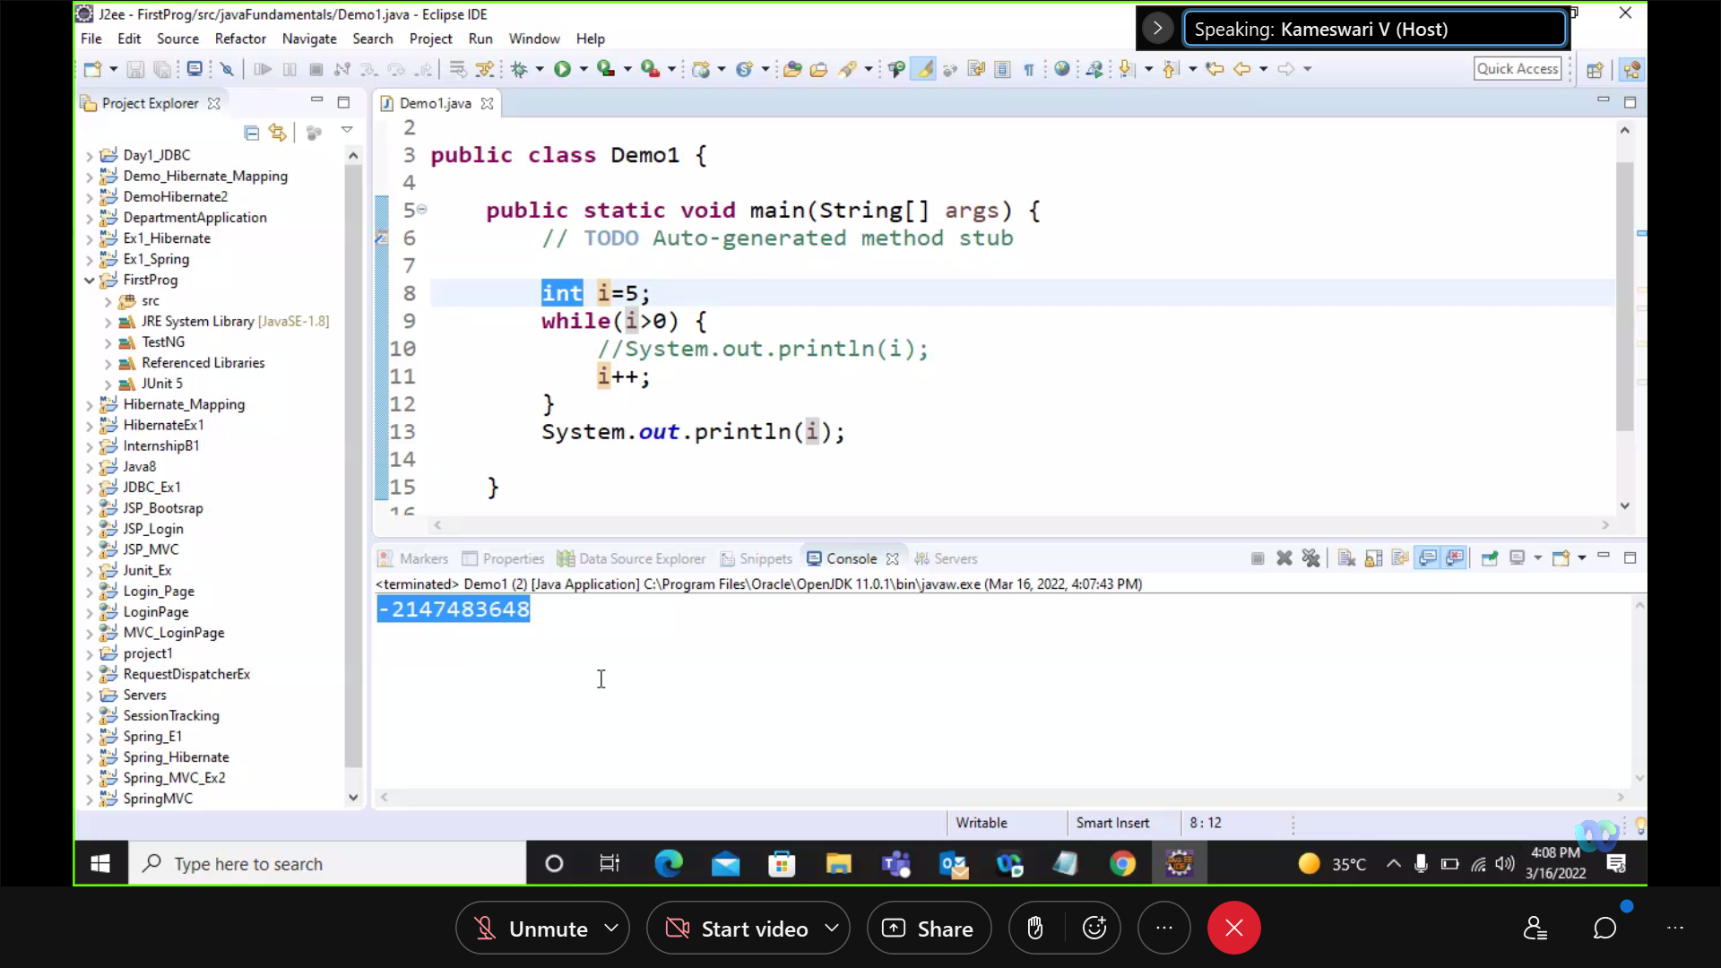

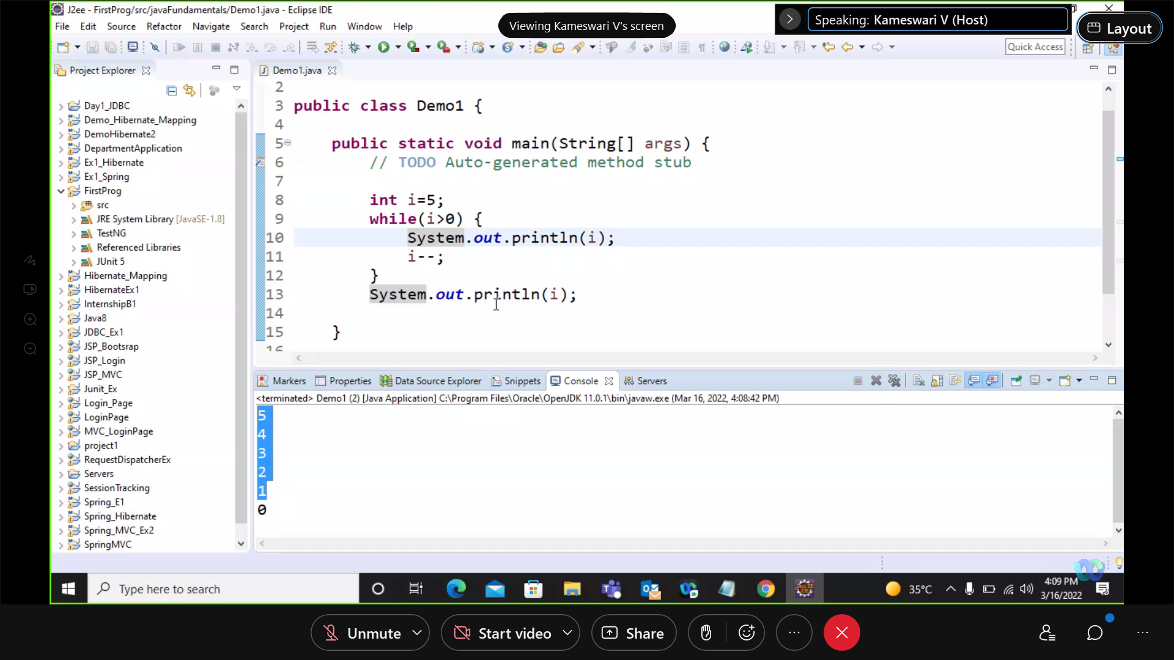

Do- while:

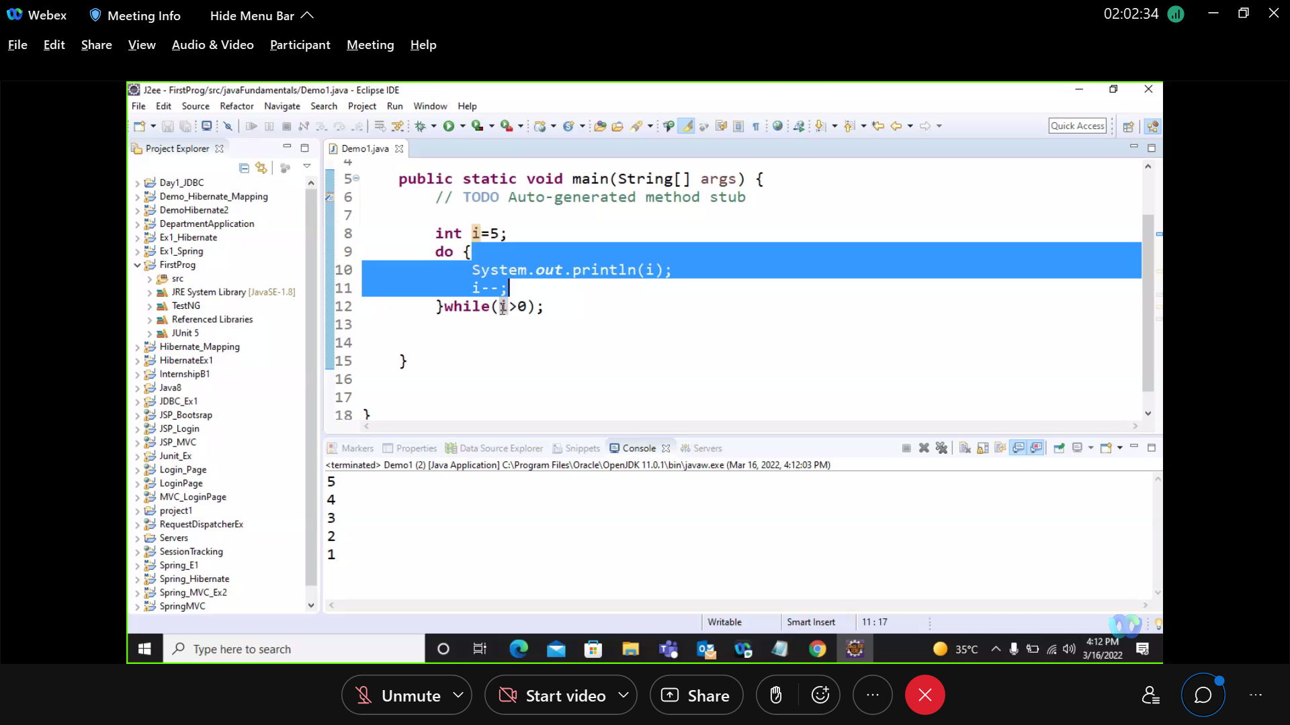

For :

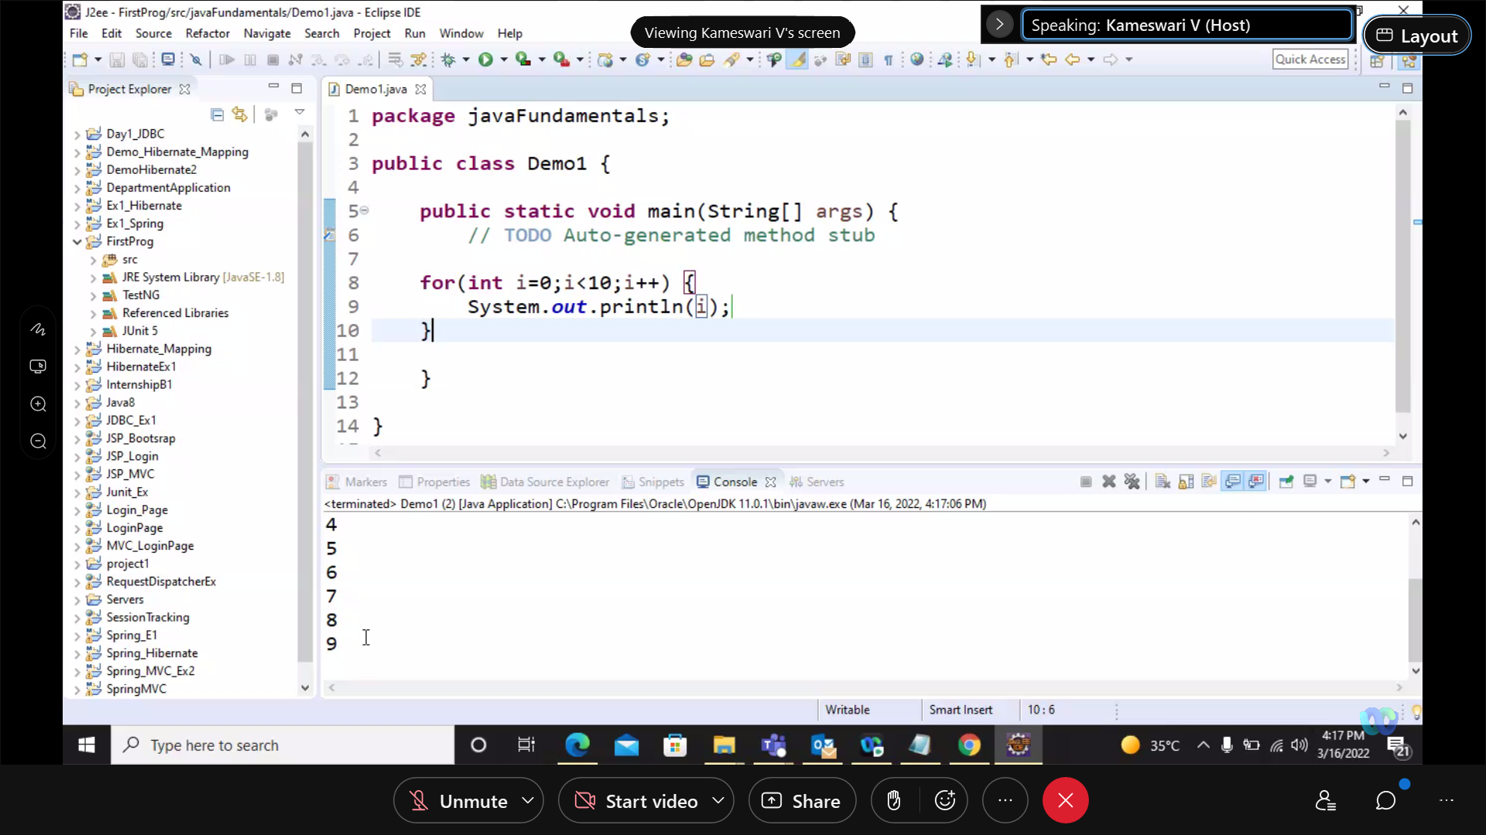

public class Demo1 { public static void main(String[] args) { // TODO Auto-generated method stub for(int i=0;i<10;i++) { System.out.println(i); if(i==5) break; } }}

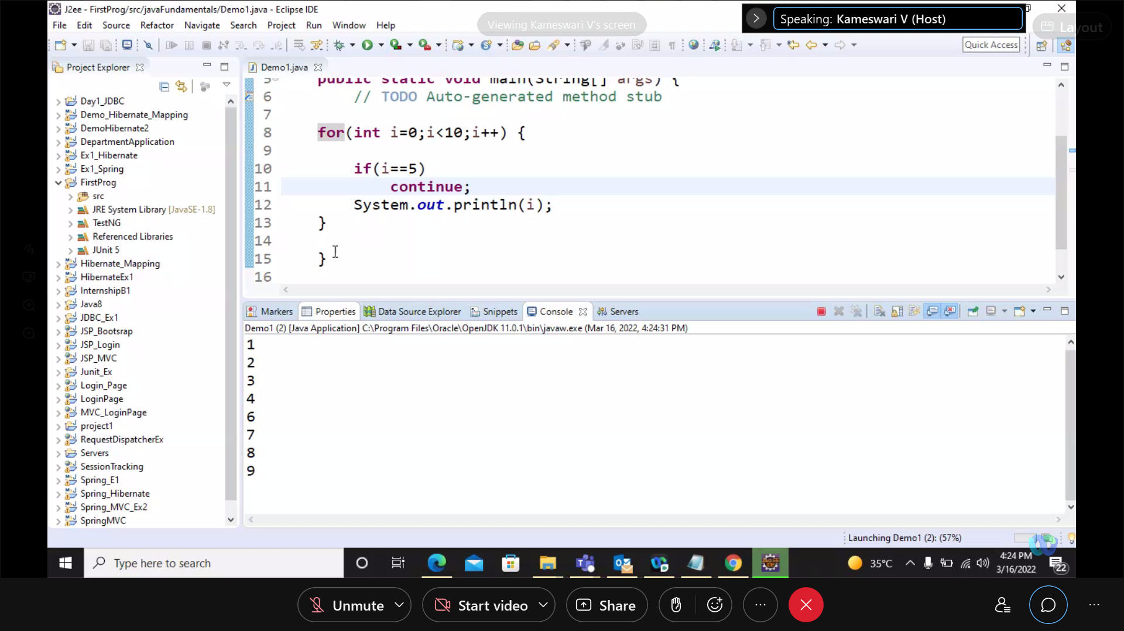

public class Demo1 { public static void main(String[] args) { // TODO Auto-generated method stub for(int i=0;i<10;i++) { if(i==5) continue; System.out.println(i); } }}

* How to use Scanner to take input from user:
* For integer

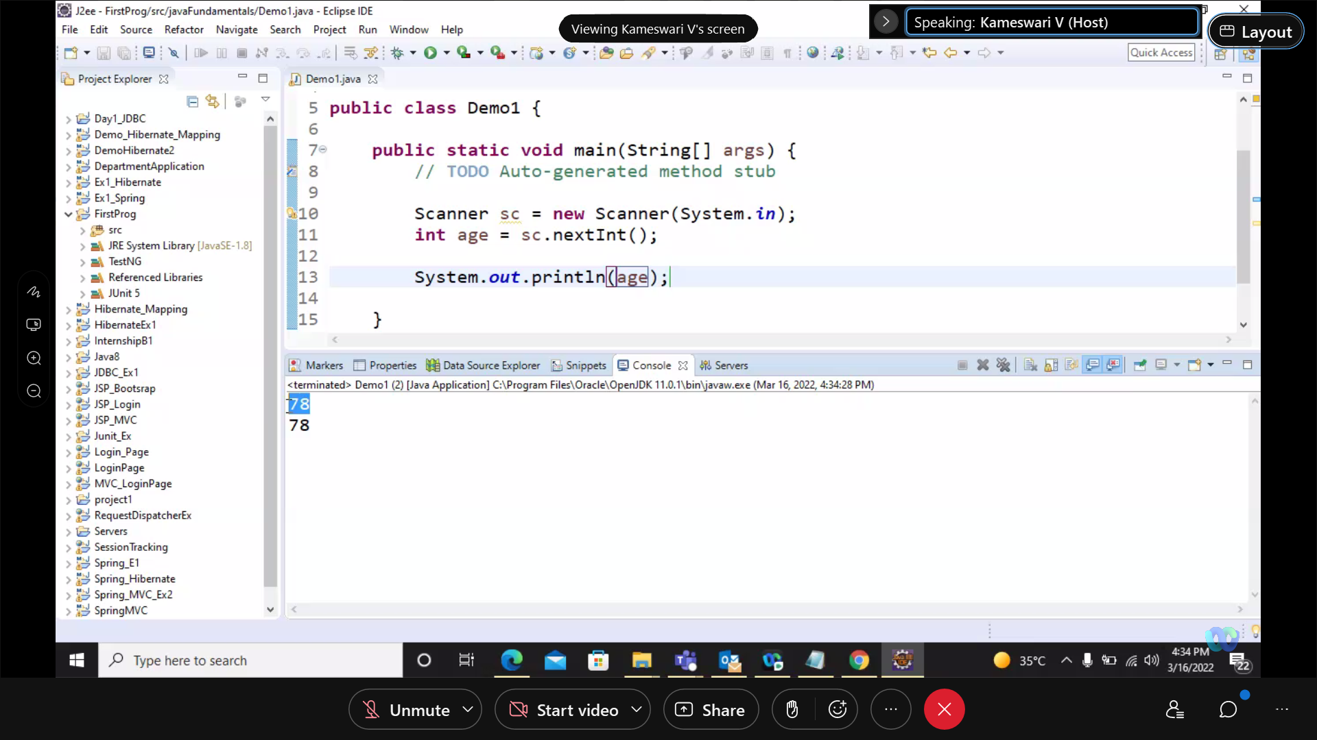

Create Scanner object as sc

* For String:

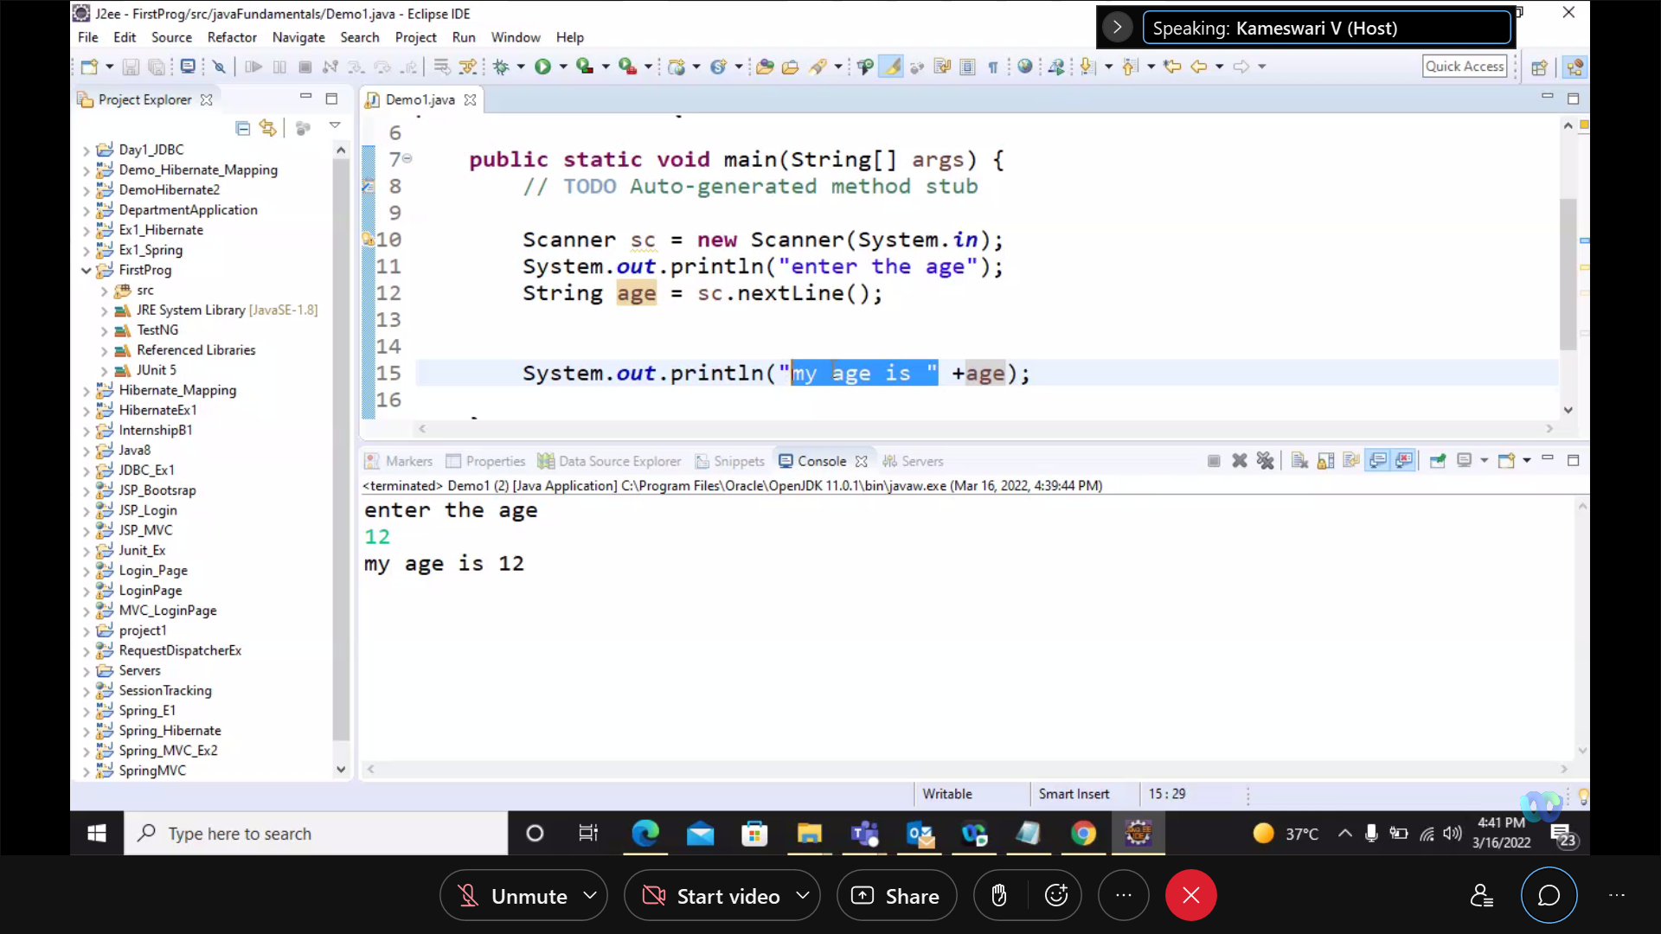

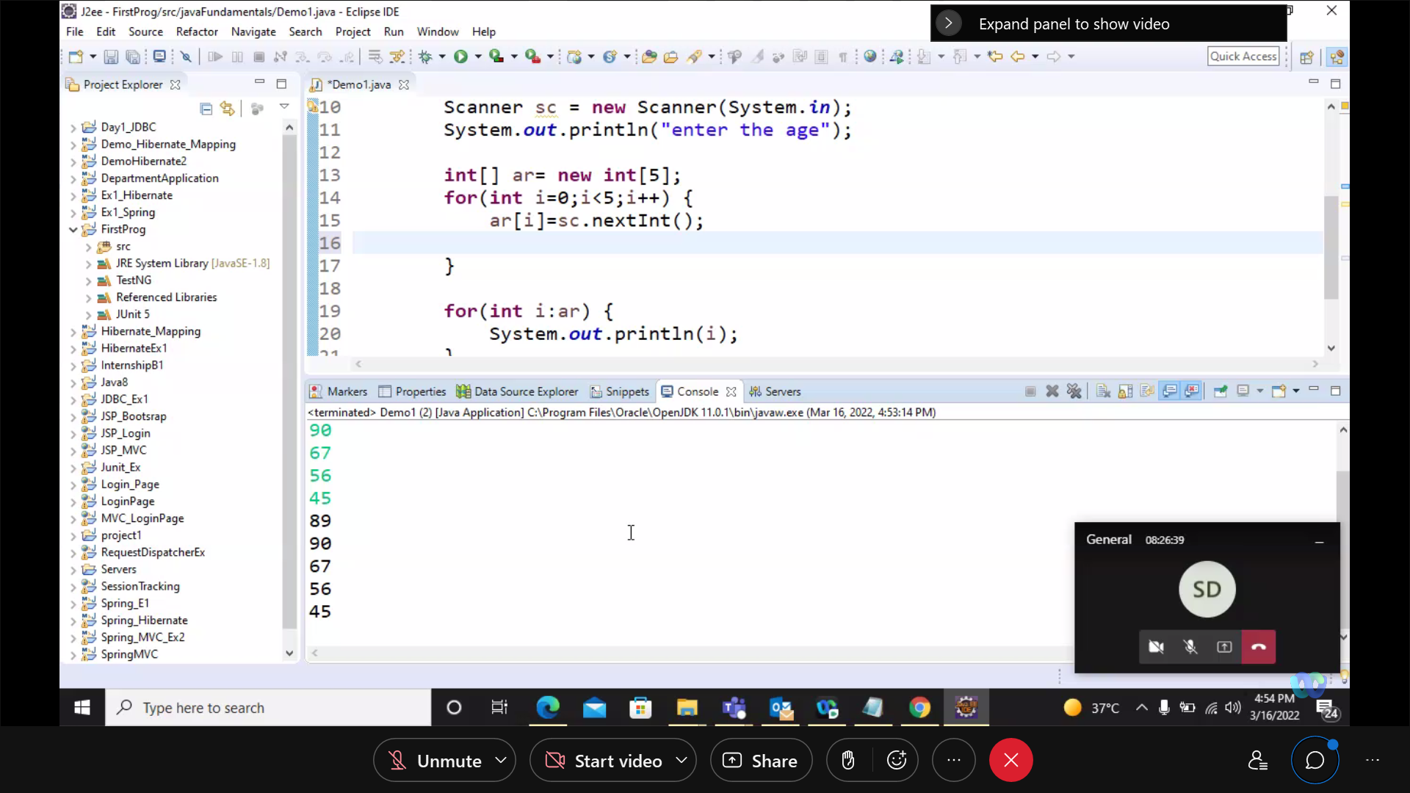

public class Demo1 { public static void main(String[] args) { // TODO Auto-generated method stub Scanner sc = new Scanner(System.in); System.out.println("enter the age"); int[] ar= new int[5]; for(int i=0;i<5;i++) { ar[i]=sc.nextInt(); } for(int i:ar) { System.out.println(i); } }}